Test Case: tc001_SPX_Dev5_Crear_Requisicion_Spot_Tipo_Cobro_CC
Step 1 - Enter username and password and click to button Enter : Credentials Entered
Image file-name: QC_Testing-tc001_SPX_Dev5_Crear_Requisicion_Spot_Tipo_Cobro_CC-dic. 02 2025, 06 10 57 p. m.

Image file-name: QC_Testing-tc001_SPX_Dev5_Crear_Requisicion_Spot_Tipo_Cobro_CC-dic. 02 2025, 06 10 58 p. m.

Step 2 - Select to UEN and Access to Spot Buy Requisitions : UEN Correctly selected and Correct access
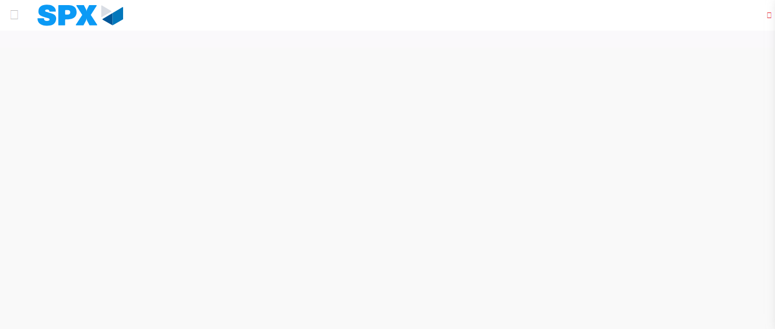Image file-name: QC_Testing-tc001_SPX_Dev5_Crear_Requisicion_Spot_Tipo_Cobro_CC-dic. 02 2025, 06 11 01 p. m.

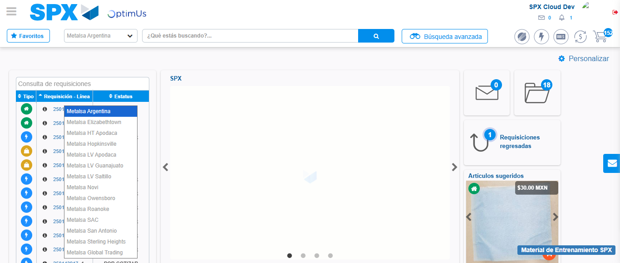Image file-name: QC_Testing-tc001_SPX_Dev5_Crear_Requisicion_Spot_Tipo_Cobro_CC-dic. 02 2025, 06 11 03 p. m.

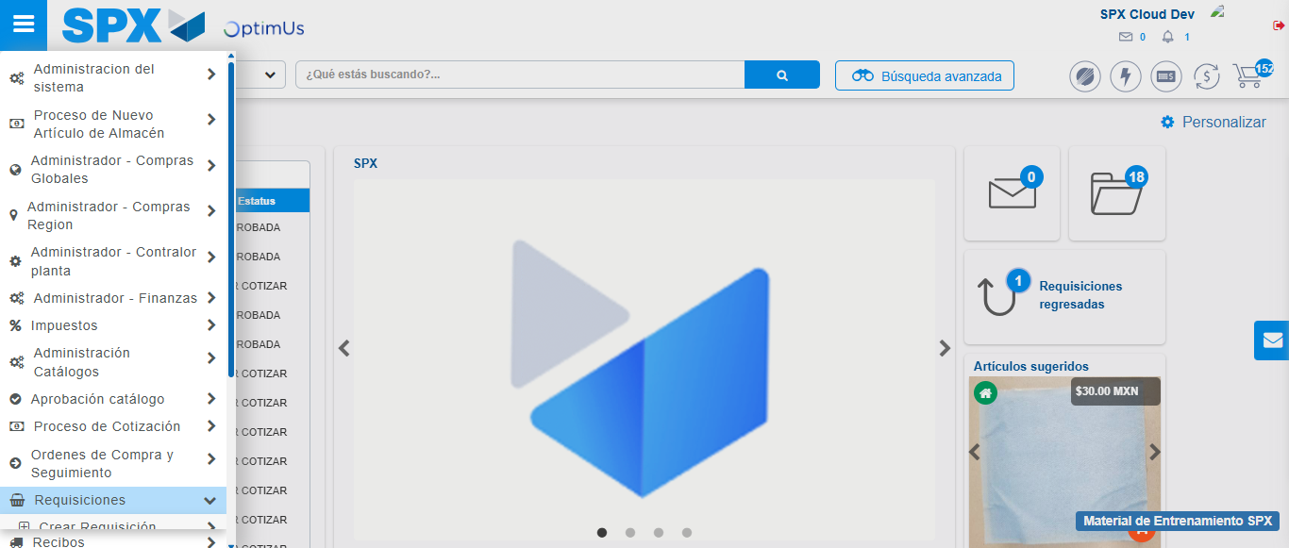Image file-name: QC_Testing-tc001_SPX_Dev5_Crear_Requisicion_Spot_Tipo_Cobro_CC-dic. 02 2025, 06 11 04 p. m.

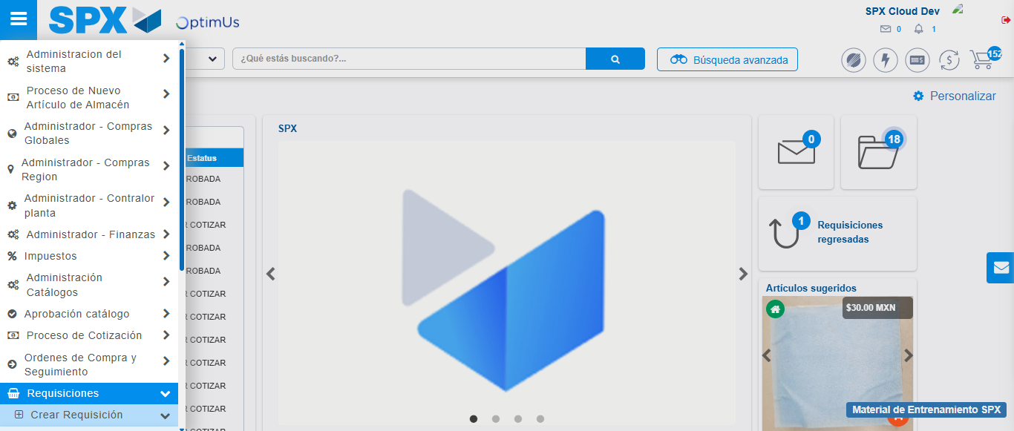Image file-name: QC_Testing-tc001_SPX_Dev5_Crear_Requisicion_Spot_Tipo_Cobro_CC-dic. 02 2025, 06 11 05 p. m.

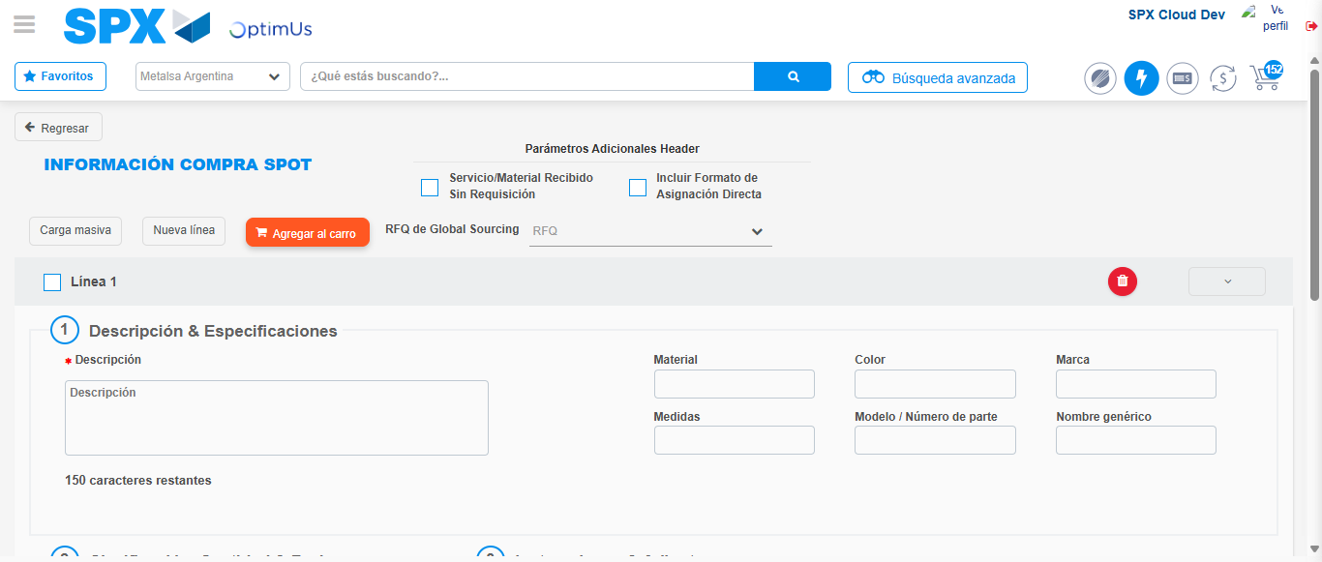Image file-name: QC_Testing-tc001_SPX_Dev5_Crear_Requisicion_Spot_Tipo_Cobro_CC-dic. 02 2025, 06 11 08 p. m.

Step 3 - Data Capture Spot Buy Requisition : Data captured correctly
Image file-name: QC_Testing-tc001_SPX_Dev5_Crear_Requisicion_Spot_Tipo_Cobro_CC-dic. 02 2025, 06 11 08 p. m.

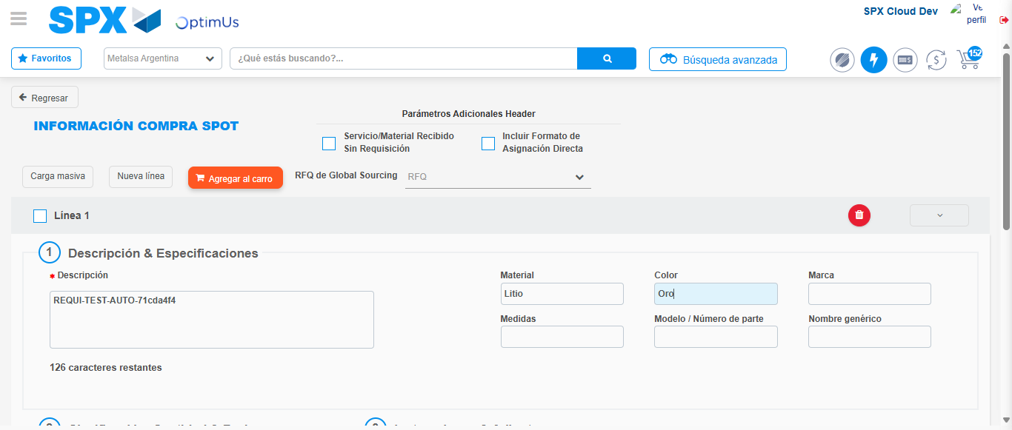Image file-name: QC_Testing-tc001_SPX_Dev5_Crear_Requisicion_Spot_Tipo_Cobro_CC-dic. 02 2025, 06 11 09 p. m.

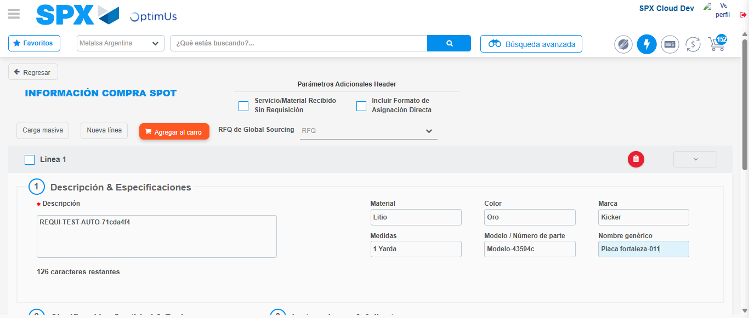Image file-name: QC_Testing-tc001_SPX_Dev5_Crear_Requisicion_Spot_Tipo_Cobro_CC-dic. 02 2025, 06 11 10 p. m.

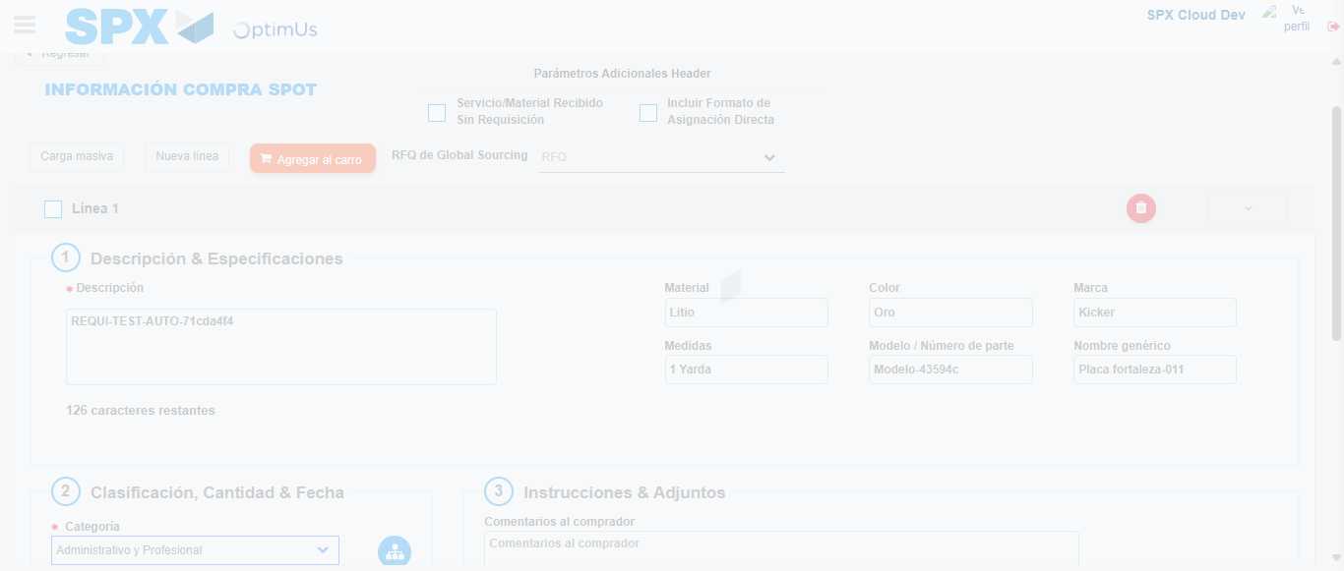Image file-name: QC_Testing-tc001_SPX_Dev5_Crear_Requisicion_Spot_Tipo_Cobro_CC-dic. 02 2025, 06 11 11 p. m.

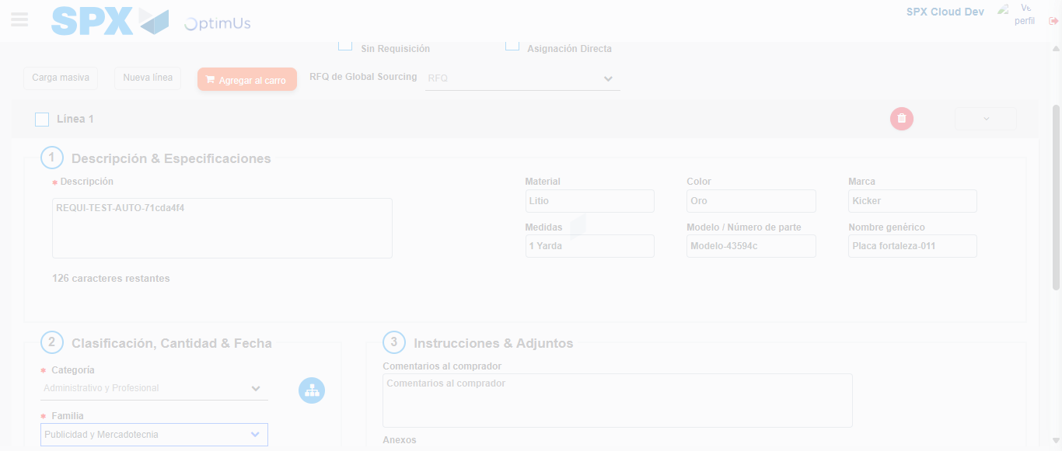Image file-name: QC_Testing-tc001_SPX_Dev5_Crear_Requisicion_Spot_Tipo_Cobro_CC-dic. 02 2025, 06 11 12 p. m.

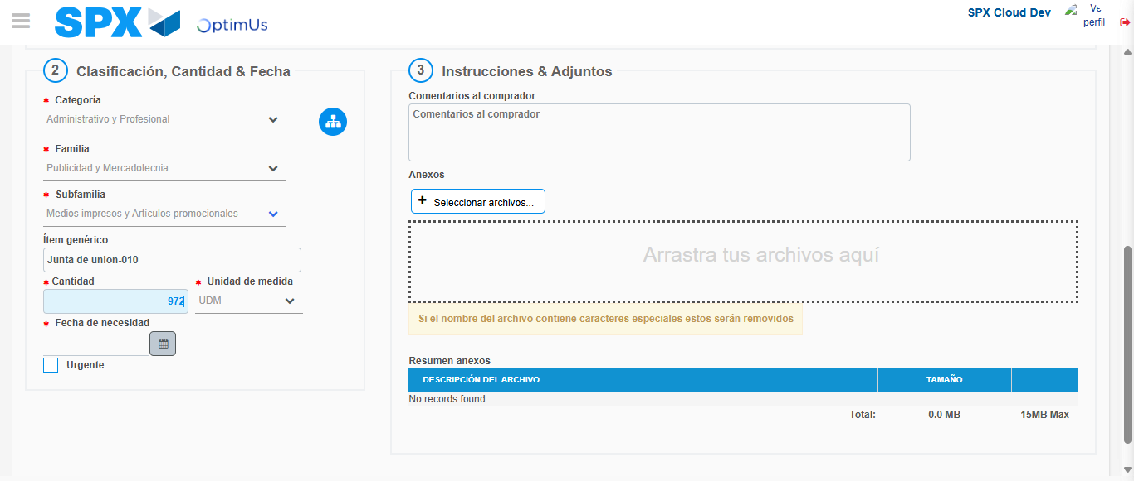Image file-name: QC_Testing-tc001_SPX_Dev5_Crear_Requisicion_Spot_Tipo_Cobro_CC-dic. 02 2025, 06 11 17 p. m.

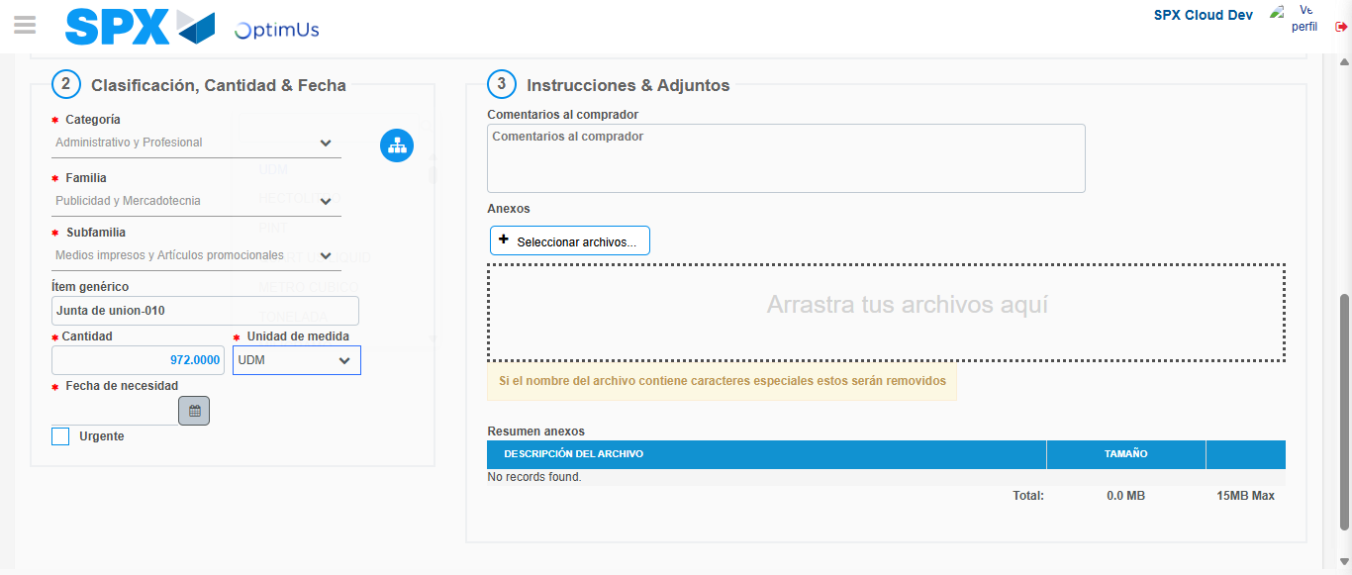Image file-name: QC_Testing-tc001_SPX_Dev5_Crear_Requisicion_Spot_Tipo_Cobro_CC-dic. 02 2025, 06 11 18 p. m.

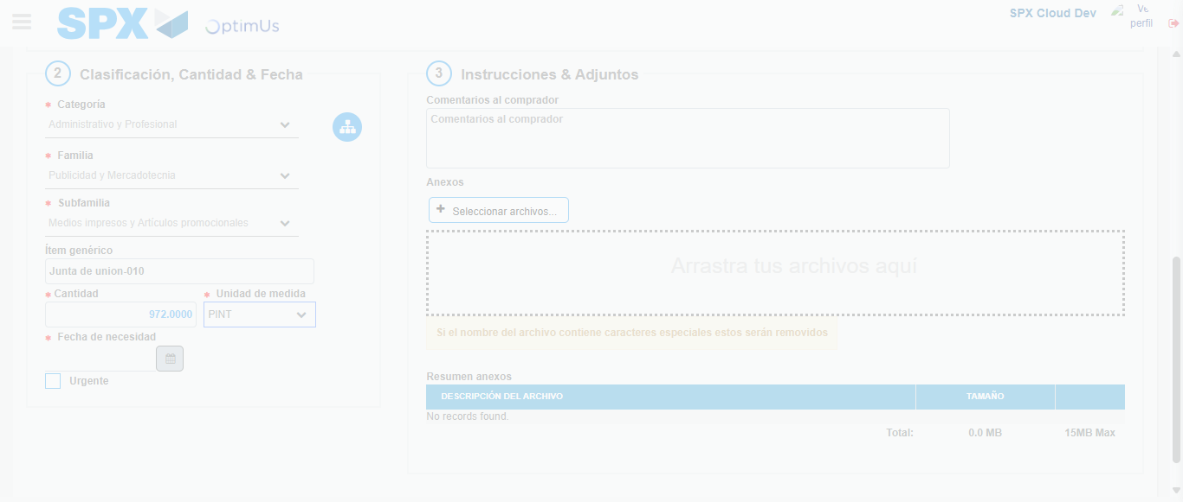Image file-name: QC_Testing-tc001_SPX_Dev5_Crear_Requisicion_Spot_Tipo_Cobro_CC-dic. 02 2025, 06 11 19 p. m.

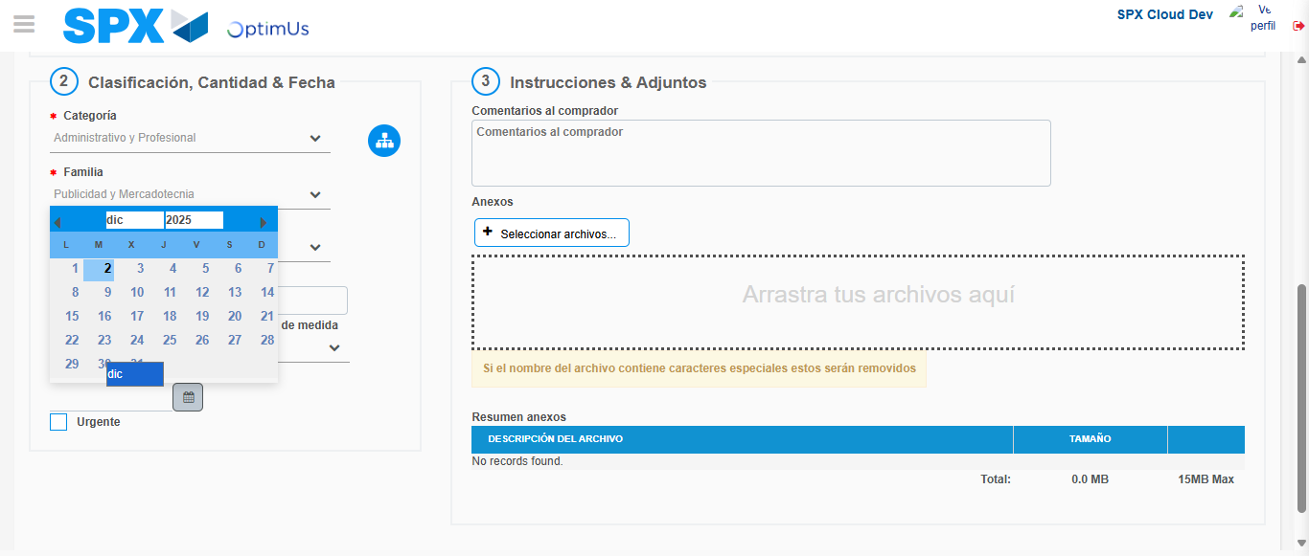Image file-name: QC_Testing-tc001_SPX_Dev5_Crear_Requisicion_Spot_Tipo_Cobro_CC-dic. 02 2025, 06 11 20 p. m.

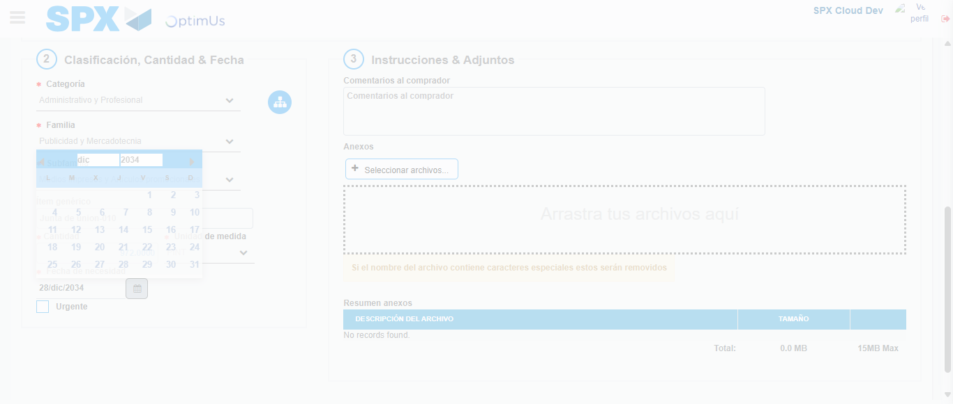Image file-name: QC_Testing-tc001_SPX_Dev5_Crear_Requisicion_Spot_Tipo_Cobro_CC-dic. 02 2025, 06 11 21 p. m.

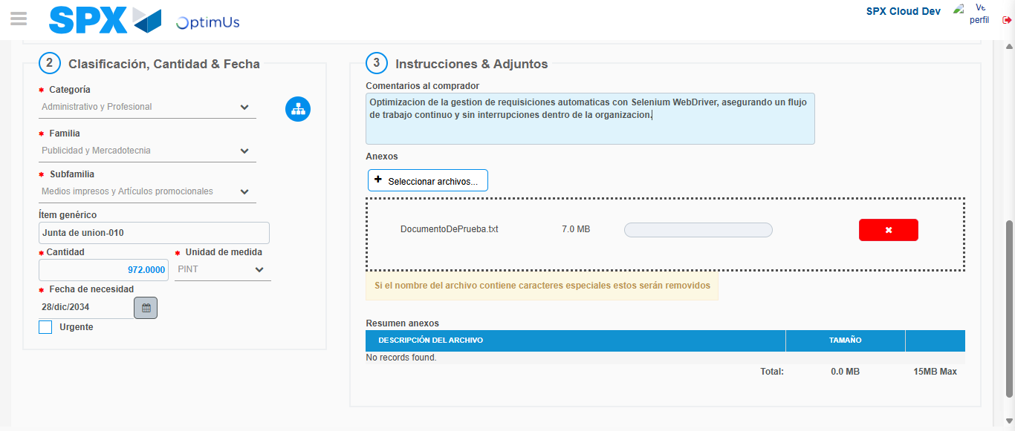Image file-name: QC_Testing-tc001_SPX_Dev5_Crear_Requisicion_Spot_Tipo_Cobro_CC-dic. 02 2025, 06 11 22 p. m.

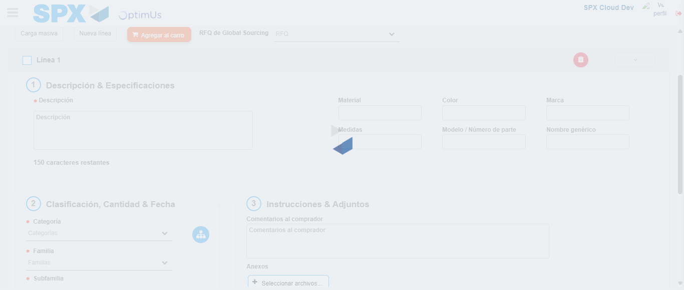Image file-name: QC_Testing-tc001_SPX_Dev5_Crear_Requisicion_Spot_Tipo_Cobro_CC-dic. 02 2025, 06 11 23 p. m.

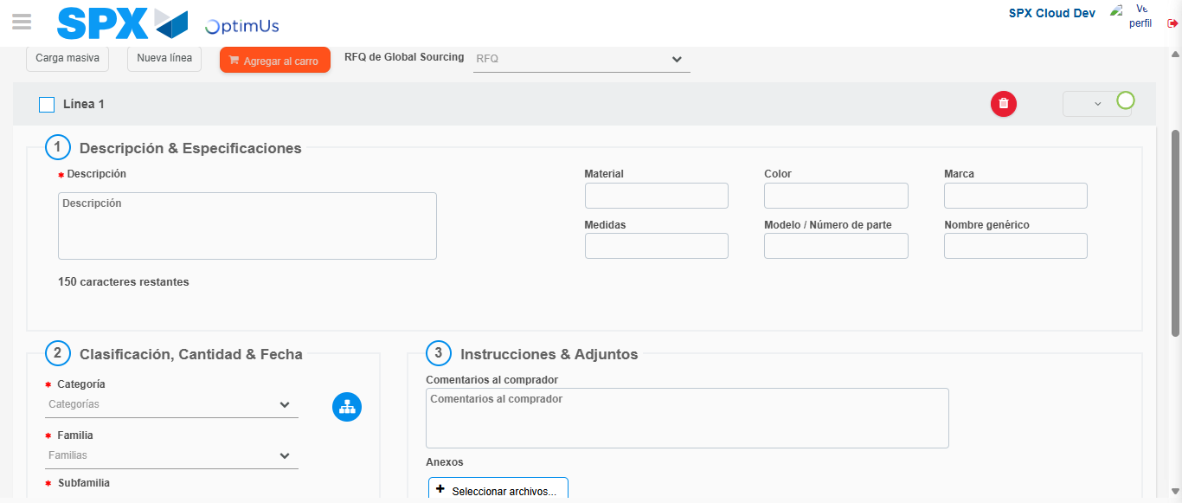Image file-name: QC_Testing-tc001_SPX_Dev5_Crear_Requisicion_Spot_Tipo_Cobro_CC-dic. 02 2025, 06 11 24 p. m.

Step 4 - Select to Requisition : Requisition Correctly selected
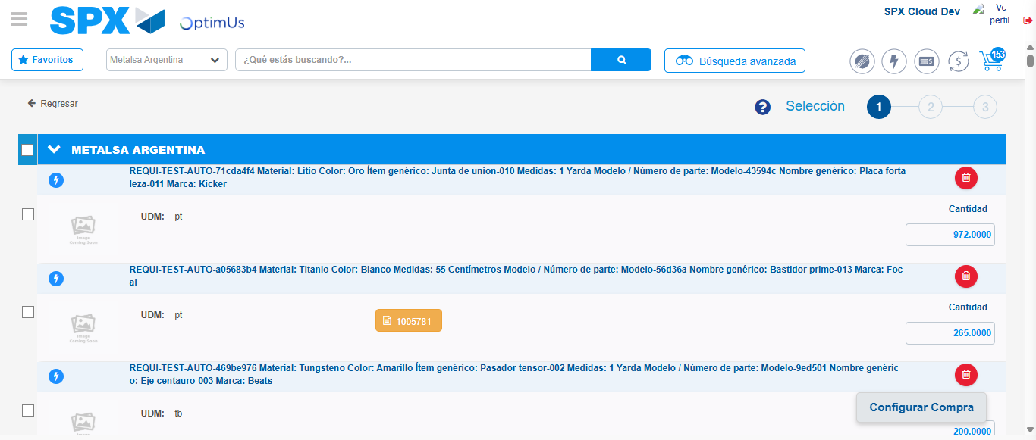Image file-name: QC_Testing-tc001_SPX_Dev5_Crear_Requisicion_Spot_Tipo_Cobro_CC-dic. 02 2025, 06 11 34 p. m.

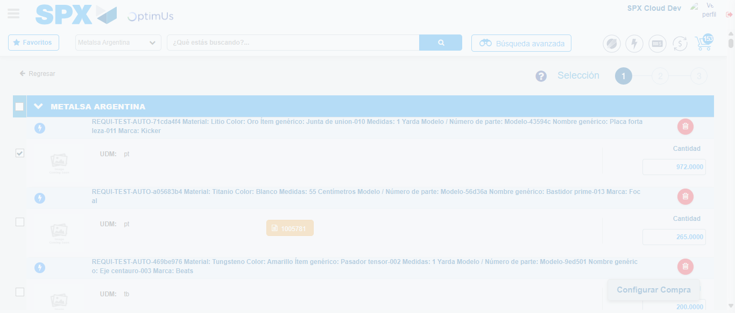Image file-name: QC_Testing-tc001_SPX_Dev5_Crear_Requisicion_Spot_Tipo_Cobro_CC-dic. 02 2025, 06 11 35 p. m.

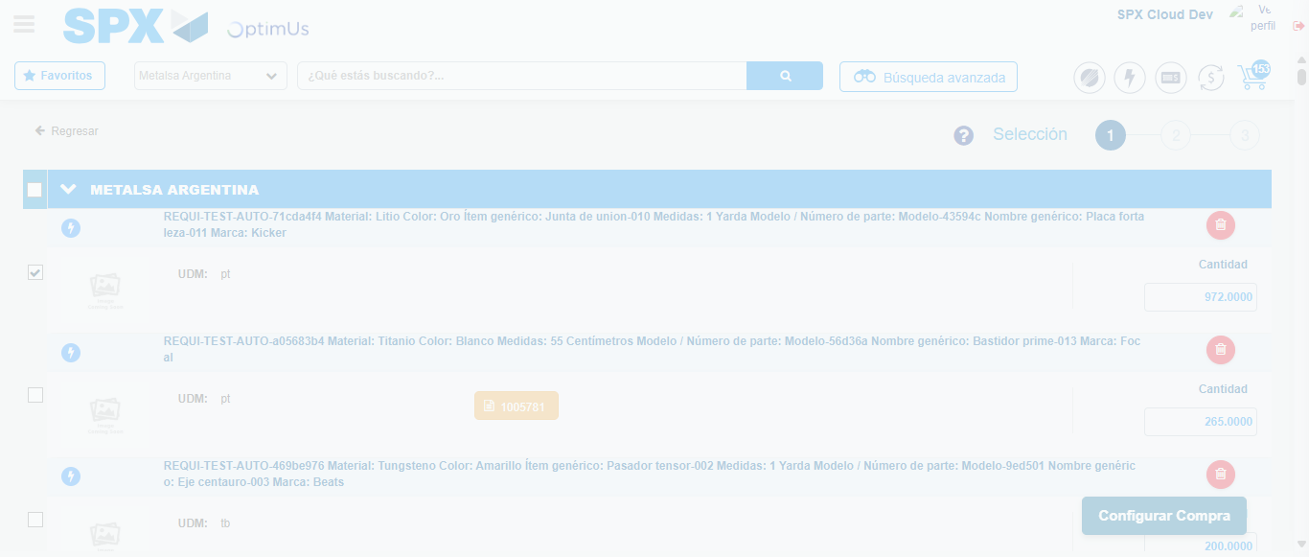Image file-name: QC_Testing-tc001_SPX_Dev5_Crear_Requisicion_Spot_Tipo_Cobro_CC-dic. 02 2025, 06 11 38 p. m.

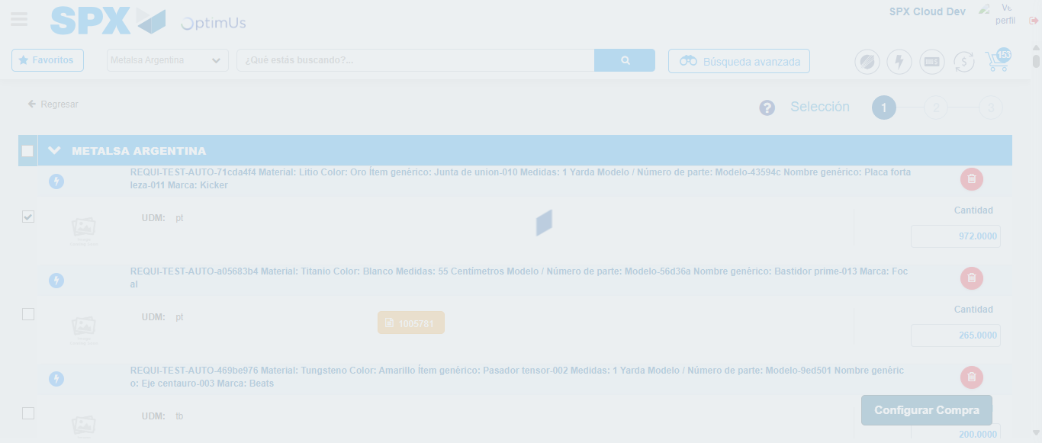Image file-name: QC_Testing-tc001_SPX_Dev5_Crear_Requisicion_Spot_Tipo_Cobro_CC-dic. 02 2025, 06 11 39 p. m.

Step 5 - Select Type Account For Requisition : Type Account Correctly selected
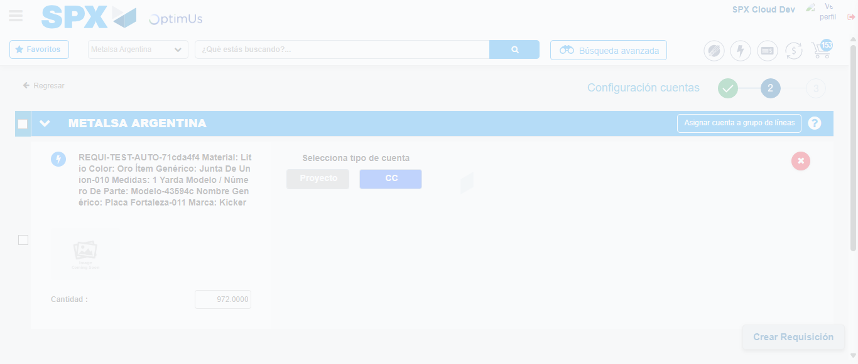Image file-name: QC_Testing-tc001_SPX_Dev5_Crear_Requisicion_Spot_Tipo_Cobro_CC-dic. 02 2025, 06 11 47 p. m.

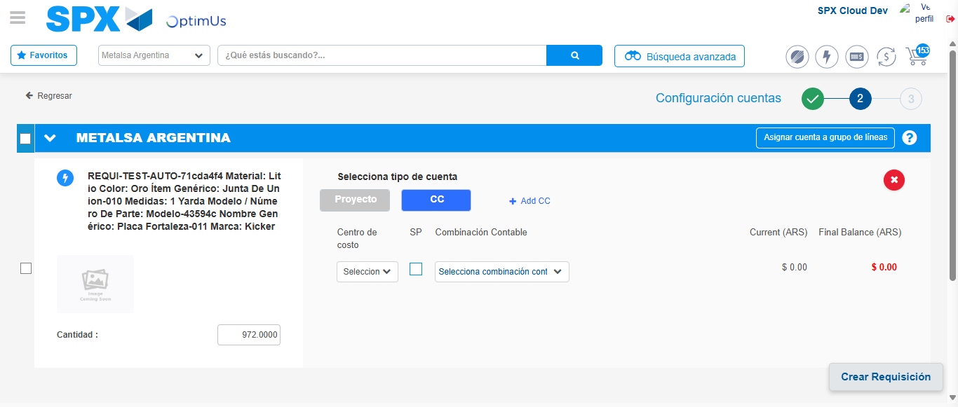Image file-name: QC_Testing-tc001_SPX_Dev5_Crear_Requisicion_Spot_Tipo_Cobro_CC-dic. 02 2025, 06 11 50 p. m.

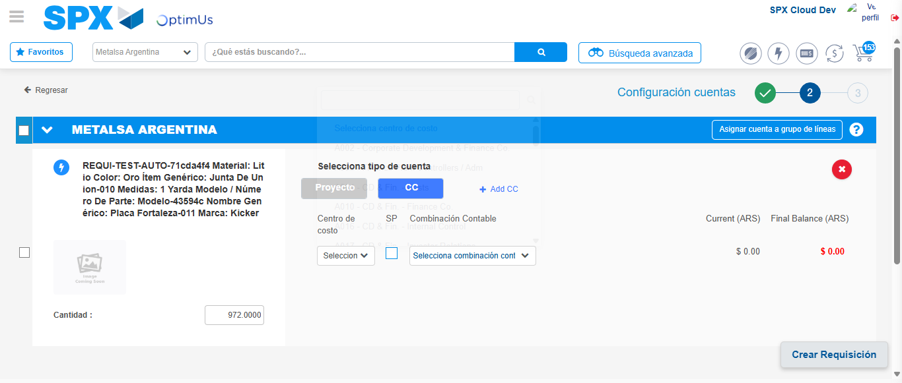Image file-name: QC_Testing-tc001_SPX_Dev5_Crear_Requisicion_Spot_Tipo_Cobro_CC-dic. 02 2025, 06 11 53 p. m.

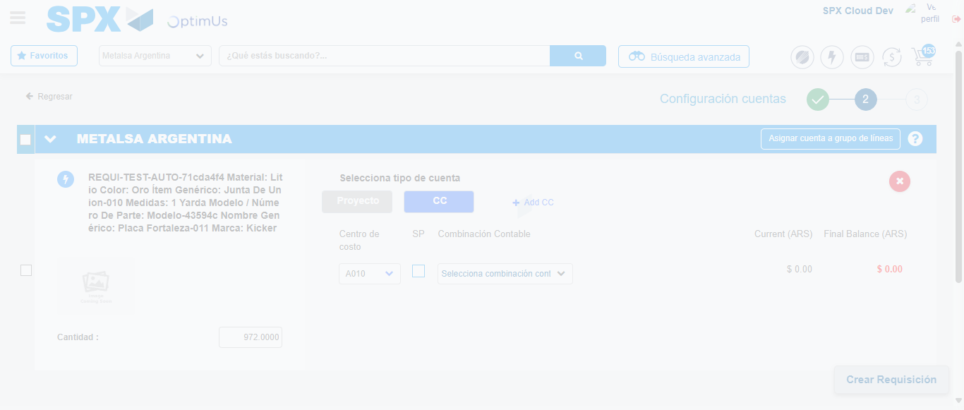Image file-name: QC_Testing-tc001_SPX_Dev5_Crear_Requisicion_Spot_Tipo_Cobro_CC-dic. 02 2025, 06 11 54 p. m.

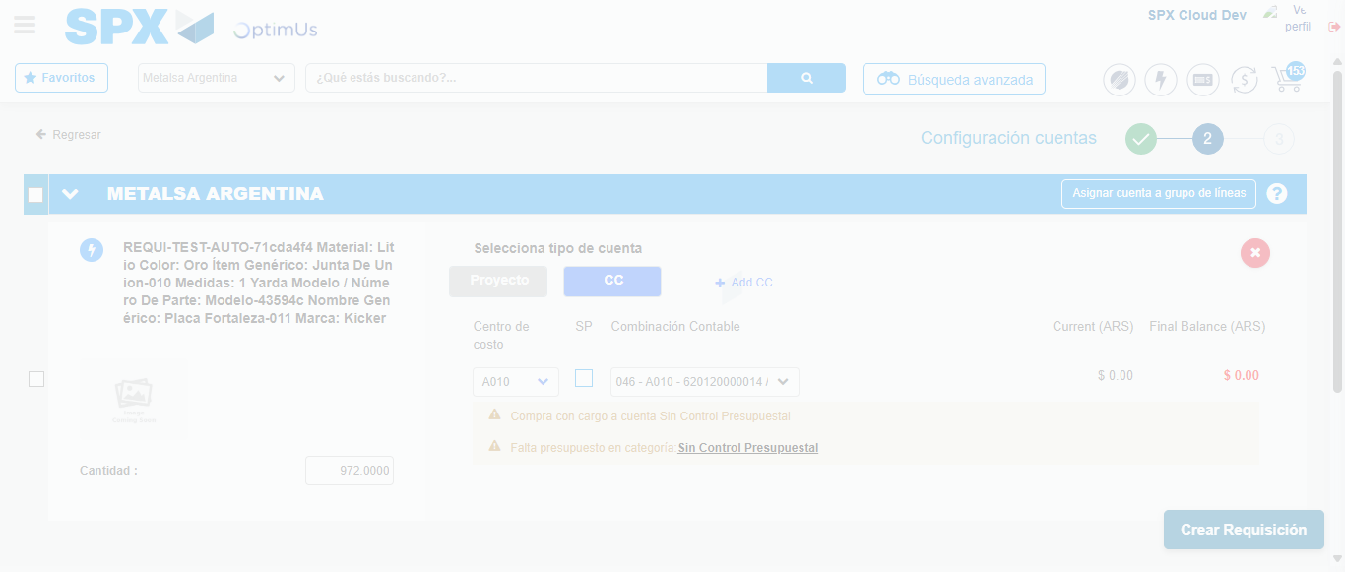Image file-name: QC_Testing-tc001_SPX_Dev5_Crear_Requisicion_Spot_Tipo_Cobro_CC-dic. 02 2025, 06 11 57 p. m.

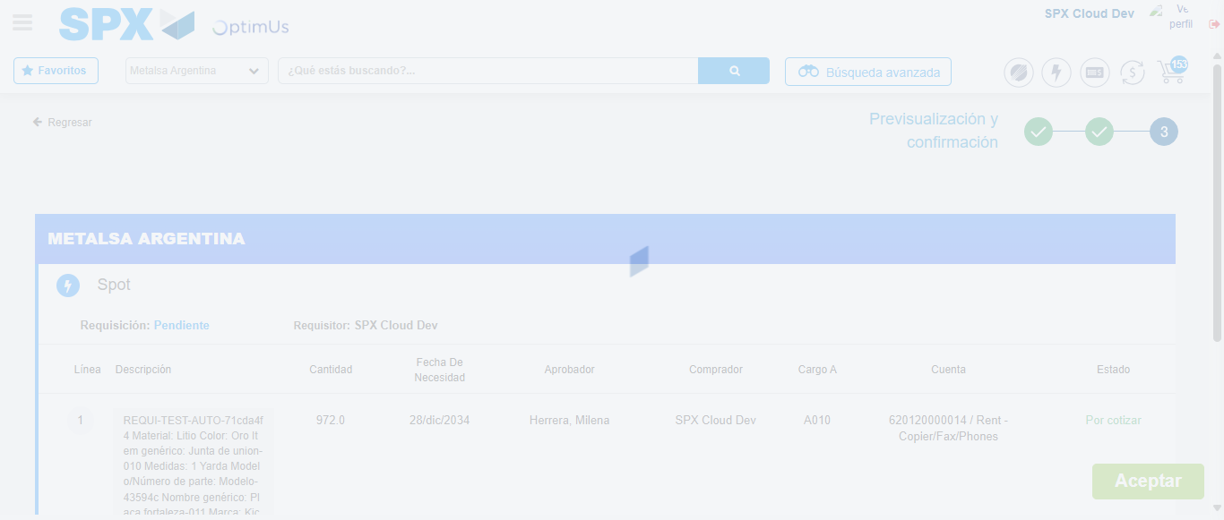Image file-name: QC_Testing-tc001_SPX_Dev5_Crear_Requisicion_Spot_Tipo_Cobro_CC-dic. 02 2025, 06 11 58 p. m.

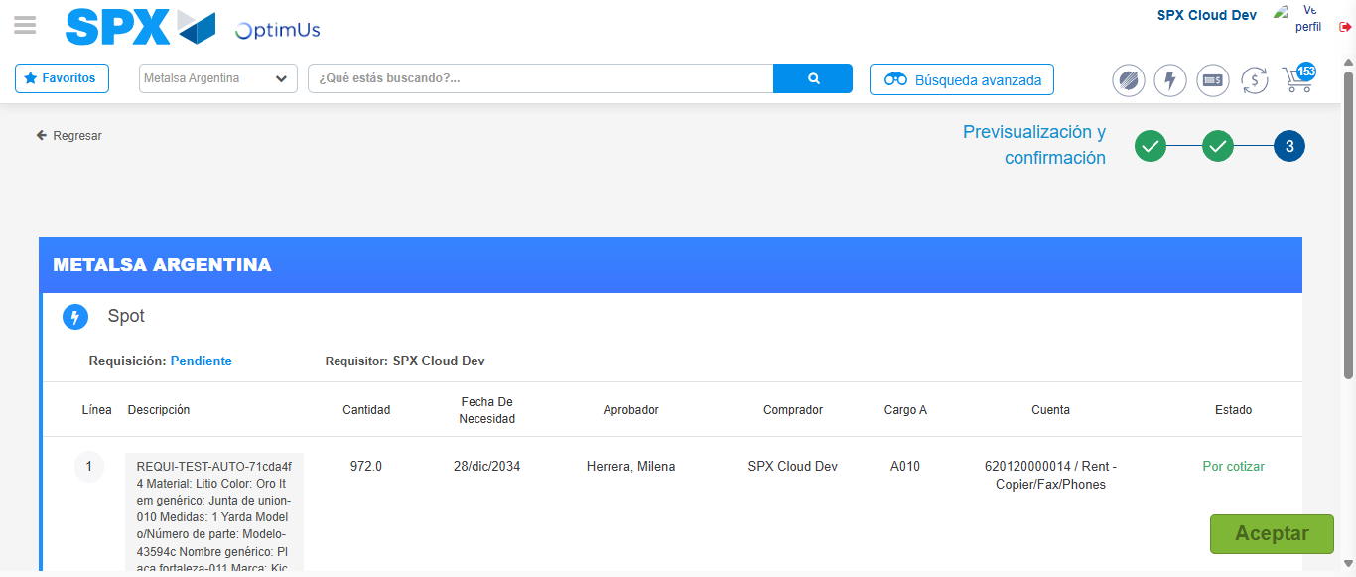Image file-name: QC_Testing-tc001_SPX_Dev5_Crear_Requisicion_Spot_Tipo_Cobro_CC-dic. 02 2025, 06 12 01 p. m.

Step 6 - Accept to Requisition : Requisition Accepted
Image file-name: QC_Testing-tc001_SPX_Dev5_Crear_Requisicion_Spot_Tipo_Cobro_CC-dic. 02 2025, 06 12 01 p. m.

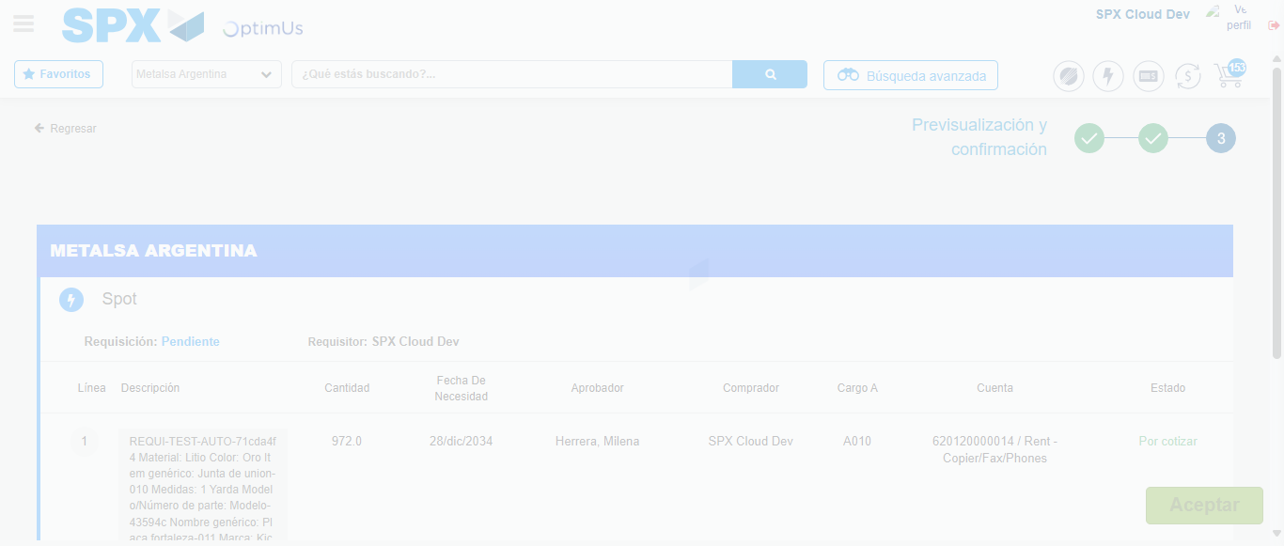Image file-name: QC_Testing-tc001_SPX_Dev5_Crear_Requisicion_Spot_Tipo_Cobro_CC-dic. 02 2025, 06 12 02 p. m.

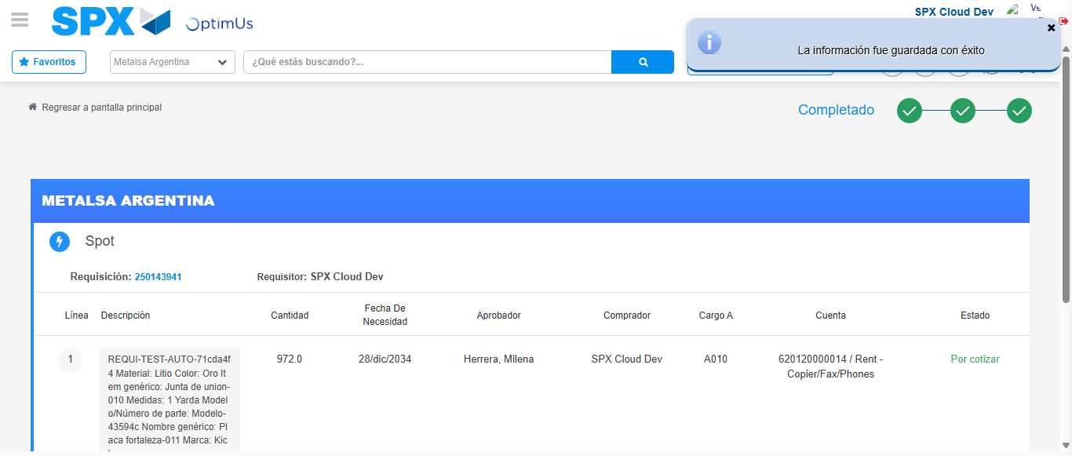Image file-name: QC_Testing-tc001_SPX_Dev5_Crear_Requisicion_Spot_Tipo_Cobro_CC-dic. 02 2025, 06 12 05 p. m.

